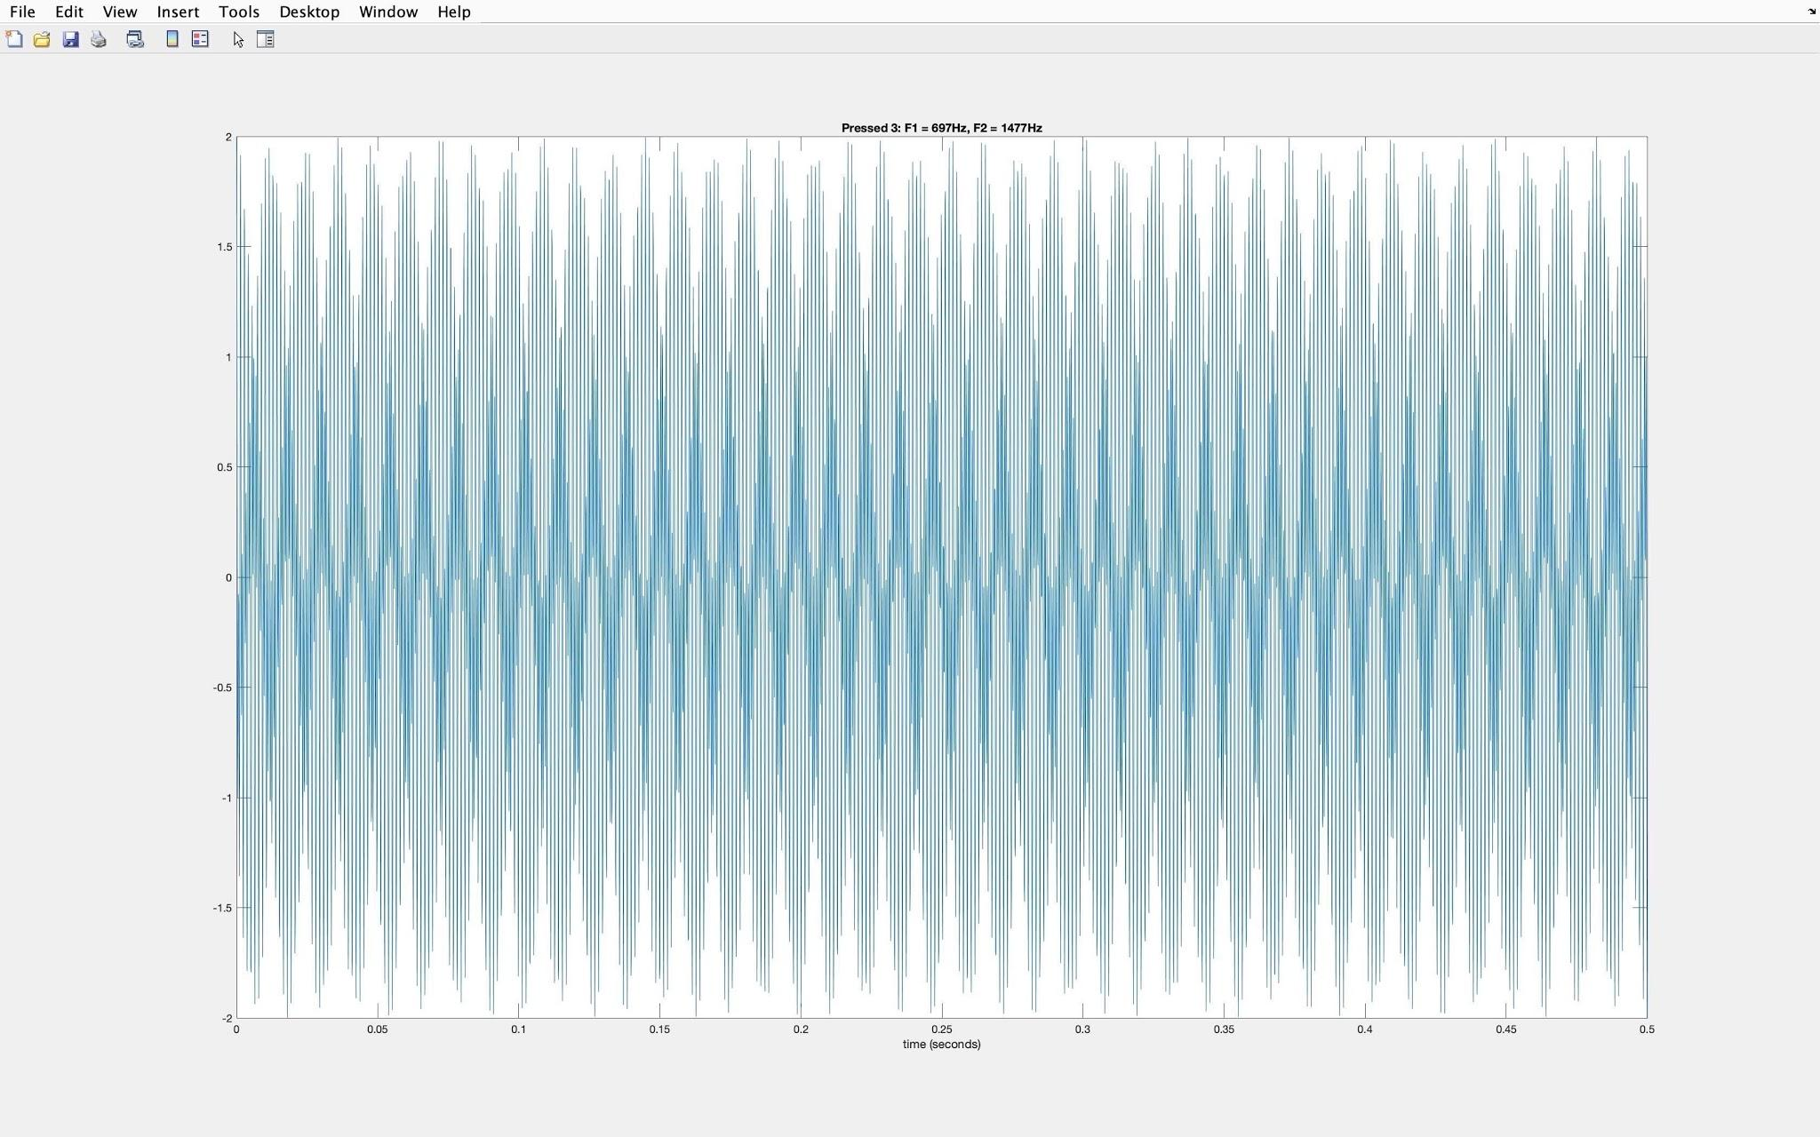

**Figure 1. Waveform for ‘3’**

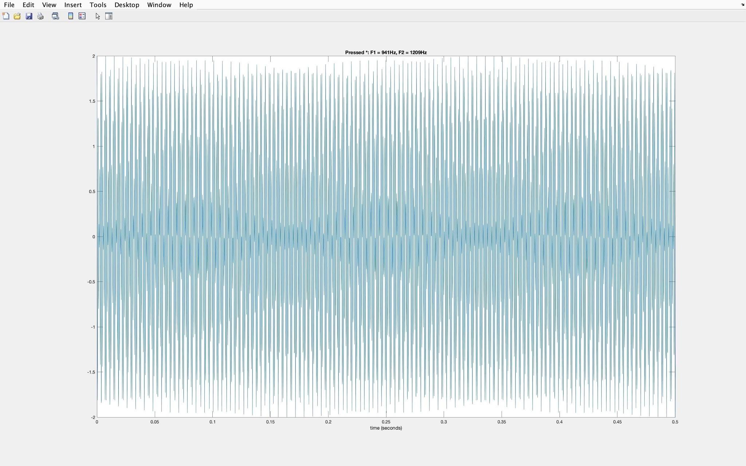

**Figure 2. Waveform for ‘*’**